
LESSON NOTE | DETAILED EXPLANATORY NOTES

BIOENERGETICS
Photosynthesis - Light & Dark reactions

GRADE 12- BIOLOGY

■ ■ ■

What are Bioenergetics?
Bioenergetics is the branch of biology that studies how living organisms obtain, transform, store, and use energy. Every biological process, from growth and movement to reproduction and cellular repair, requires energy. Understanding how energy flows through living systems is therefore essential for understanding life itself.
The ultimate source of energy for almost all life on Earth is the Sun. Solar energy enters ecosystems through the process of photosynthesis, in which plants, algae, and some bacteria capture light energy and convert it into chemical energy stored in glucose. This stored energy is then transferred through food chains and used by living organisms to power cellular activities.
Bioenergetics examines not only how energy is captured, but also how it is transferred, stored, and released within cells. The energy captured by photosynthesis is eventually released through cellular respiration and converted into forms that cells can use directly.

Energy Processes in Living Things
The flow of energy through living organisms involves several interconnected processes:
- Photosynthesis - captures light energy and converts it into chemical energy stored in glucose.
- Cellular Respiration - breaks down glucose to release energy that can be used by cells.
- ATP Cycling - stores and transfers energy within cells using adenosine triphosphate (ATP), often called the cell's energy currency.
- Energy Flow - describes the one-way movement of energy through ecosystems from producers to consumers and decomposers.
Together, these processes explain how energy enters biological systems, moves through organisms, and ultimately flows through ecosystems.

Photosynthesis

Key Learning Outcomes
By the end of this lesson, students should be able to:
- Write both the word equation and balanced chemical equation for photosynthesis and identify where the process occurs.
- Describe the structure of the chloroplast and explain how its different parts are adapted for photosynthesis.
- Distinguish between the light-dependent reactions and the light-independent reactions (Calvin cycle).
- Explain the role of chlorophyll in absorbing light energy.
- Describe the roles of water, ATP, and NADPH in the light-dependent reactions.
- Outline the major stages of the Calvin cycle, including carbon fixation, reduction, and regeneration of RuBP.
- Explain how glucose is produced from carbon dioxide through photosynthesis.
- Describe the limiting factors of photosynthesis, including light intensity, carbon dioxide concentration, and temperature.
- Interpret graphs showing the effects of limiting factors on the rate of photosynthesis.
- Explain the importance of photosynthesis for life, ecosystems, agriculture, and the global carbon cycle.

What is Photosynthesis?
Photosynthesis is the biological process by which green plants, algae, and certain bacteria capture light energy from the Sun and convert it into chemical energy stored in glucose. During this process, carbon dioxide from the atmosphere and water from the environment are used to produce glucose, while oxygen is released as a by-product.
Photosynthesis is one of the most important biochemical processes on Earth because it provides the primary source of energy for almost all living organisms. The glucose produced during photosynthesis serves as both an energy source and a raw material for growth, while the oxygen released supports aerobic respiration in most living things.
The overall balanced equation for photosynthesis is:
6CO₂ + 6H₂O + Light Energy → C₆H₁₂O₆ + 6O₂
In words:
Carbon dioxide + Water + Light Energy → Glucose + Oxygen
Photosynthesis occurs mainly in the chloroplasts of plant cells, particularly in the leaves where light can be absorbed efficiently. The process relies on the green pigment chlorophyll, which captures light energy and initiates the reactions of photosynthesis.
Photosynthesis can be viewed as a process of energy conversion:
Light Energy → Chemical Energy (Glucose)
The chemical energy stored in glucose can later be released through cellular respiration to produce ATP, the energy currency used by cells.
Photosynthesis takes place in two interconnected stages:
Light-Dependent Reactions
These reactions occur in the thylakoid membranes of the chloroplast and require light energy. During this stage, light is absorbed by chlorophyll, water is split, oxygen is released, and the energy-rich molecules ATP and NADPH are produced.
Light-Independent Reactions (Calvin Cycle)
These reactions occur in the stroma of the chloroplast. They do not directly require light but depend on the ATP and NADPH produced during the light-dependent reactions. During the Calvin cycle, carbon dioxide is converted into glucose and other carbohydrates.
Together, these two stages allow plants to capture solar energy and store it in a form that can be used by living organisms throughout ecosystems.
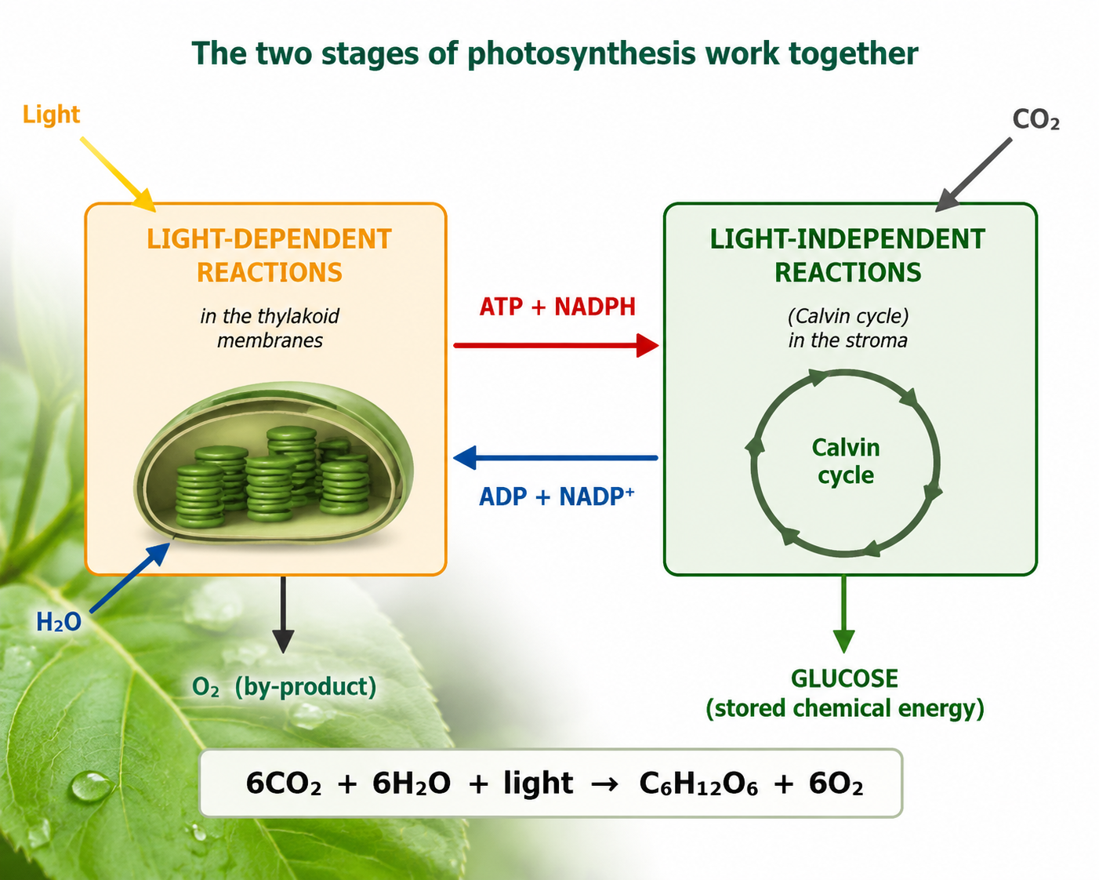
Figure 1: An overview of photosynthesis - the light reactions feed ATP and NADPH into the Calvin cycle.

Photosynthesis - Terminologies and Concepts
Understanding photosynthesis requires familiarity with several important structures, molecules, and processes that work together to capture and convert light energy into chemical energy.
- Chloroplast: The specialized organelle found in plant and algal cells where photosynthesis takes place.
- Chlorophyll: The green photosynthetic pigment that absorbs light energy, particularly red and blue wavelengths, and initiates the light-dependent reactions.
- Thylakoid: A flattened membrane sac within the chloroplast that contains chlorophyll and other pigments involved in capturing light energy.
- Grana (Granum): Stacks of thylakoids that provide a large surface area for the light-dependent reactions.
- Stroma: The fluid-filled region surrounding the thylakoids where the Calvin cycle takes place.
- Light-Dependent Reactions: Reactions that require light energy to produce ATP and NADPH and release oxygen through the splitting of water.
- Light-Independent Reactions (Calvin Cycle): Reactions that use ATP and NADPH to convert carbon dioxide into glucose and other carbohydrates.
- ATP (Adenosine Triphosphate): The primary energy-carrying molecule that provides energy for cellular processes.
- NADPH: An electron carrier that supplies reducing power for the synthesis of glucose during the Calvin cycle.
- Limiting Factor: Any factor that restricts the rate of photosynthesis because it is in shortest supply relative to the plant's needs.
Together, these structures and molecules enable plants to capture solar energy and convert it into chemical energy that supports life on Earth.

The Chloroplast - Where It Happens
Photosynthesis takes place within specialized organelles called chloroplasts, which are abundant in the cells of leaves and other green plant tissues. The chloroplast is highly organized, with different regions adapted for specific stages of photosynthesis.
Inside the chloroplast are stacks of flattened membrane sacs called thylakoids. These stacks are known as grana (singular: granum). The thylakoid membranes contain chlorophyll and the proteins required for the light-dependent reactions. Their extensive membrane surface provides a large area for capturing light energy and producing ATP and NADPH.
Surrounding the grana is the stroma, a fluid-filled region containing the enzymes required for the Calvin cycle. Here, carbon dioxide is converted into glucose using the ATP and NADPH produced during the light-dependent reactions.
This arrangement creates an efficient division of labor within the chloroplast:
- Thylakoids and Grana → Light-dependent reactions
- Stroma → Calvin cycle (light-independent reactions)
By separating these processes into specialized regions, chloroplasts maximize the efficiency of photosynthesis and enable plants to convert solar energy into chemical energy effectively.
The structure of the chloroplast is therefore closely related to its function, with each component contributing to the overall process of photosynthesis.

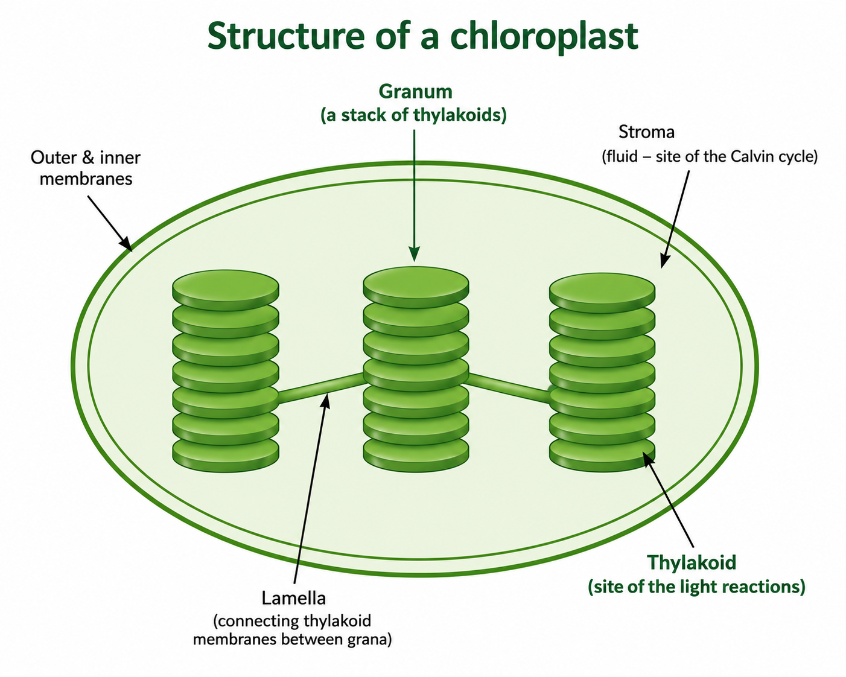
Figure 2: The chloroplast - thylakoid membranes (light reactions) within a fluid stroma (Calvin cycle).

Stage 1 - The Light-Dependent Reactions
The light-dependent reactions occur in the thylakoid membranes of the chloroplast and require light energy to proceed. Their main purpose is to capture solar energy and convert it into the chemical energy carriers ATP and NADPH, which will be used in the Calvin cycle.
The process begins when chlorophyll absorbs light energy. This energy excites electrons within the chlorophyll molecules, raising them to a higher energy level. These high-energy electrons leave the chlorophyll and enter an electron transport chain located in the thylakoid membrane.
As electrons move through the electron transport chain, they gradually lose energy. This released energy is used to produce ATP, the cell's energy-carrying molecule.
The electrons lost by chlorophyll must be replaced. This occurs through photolysis, the splitting of water molecules using light energy. During photolysis:
2H₂O → 4H⁺ + 4e⁻ + O₂

This process provides:
- Electrons (e⁻) to replace those lost by chlorophyll.
- Hydrogen ions (H⁺) needed for the formation of NADPH.
- Oxygen (O₂), which is released into the atmosphere as a by-product of photosynthesis.
The excited electrons and hydrogen ions are then used to reduce NADP⁺, forming NADPH, a molecule that carries high-energy electrons to the Calvin cycle.
The main products of the light-dependent reactions are:
- ATP - provides energy for the Calvin cycle.
- NADPH - provides high-energy electrons and reducing power for glucose synthesis.
- Oxygen (O₂) - released as a by-product.
These products are transferred to the second stage of photosynthesis, where they are used to convert carbon dioxide into glucose.

Summary of the Light-Dependent Reactions

Input | Process | Output
Light energy, Water, Chlorophyll | Light absorption, Photolysis, Electron transport | ATP, NADPH, Oxygen

The light-dependent reactions therefore capture solar energy and convert it into chemical energy that can be used to build carbohydrates during the Calvin cycle.
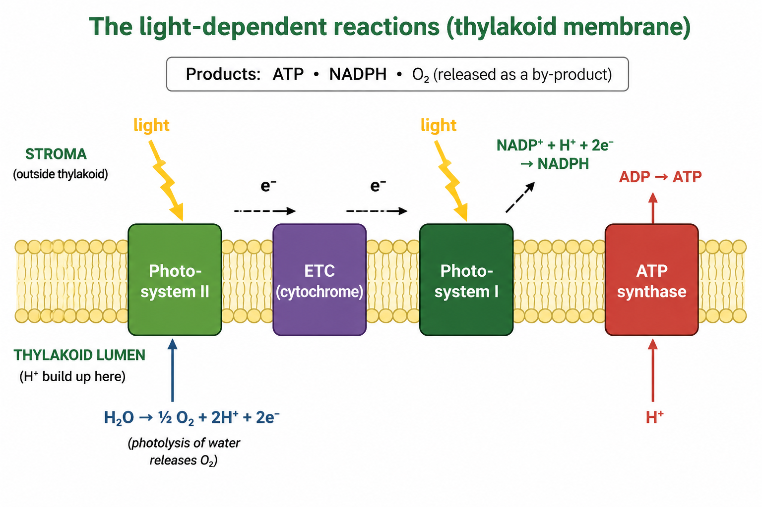
Figure 3: The light-dependent reactions - water is split, oxygen is released, and ATP and NADPH are made

Stage 2 - The Light-Independent Reactions (Calvin Cycle)
The light-independent reactions, also known as the Calvin cycle, occur in the stroma of the chloroplast. Their primary function is to use the ATP and NADPH produced during the light-dependent reactions to convert carbon dioxide into glucose and other carbohydrates.
Although these reactions are called "light-independent," they do not occur without the products of the light-dependent reactions. The Calvin cycle depends on a continuous supply of ATP and NADPH, which provide the energy and reducing power required for sugar synthesis.
The Calvin cycle consists of three main phases:
Carbon Fixation
In the first phase, carbon dioxide from the atmosphere enters the cycle and is attached to a five-carbon molecule called ribulose bisphosphate (RuBP). This reaction is catalysed by the enzyme rubisco, one of the most abundant enzymes on Earth.
The resulting six-carbon compound is unstable and quickly splits into two three-carbon molecules.
Reduction
During the reduction phase, ATP and NADPH from the light-dependent reactions are used to convert the three-carbon molecules into a higher-energy sugar molecule called glyceraldehyde-3-phosphate (G3P).
Some G3P molecules leave the cycle and are used to produce glucose and other carbohydrates needed by the plant.
Regeneration
Most of the G3P produced remains within the cycle and is used to regenerate RuBP. ATP provides the energy needed for this process. Regeneration is essential because it allows the Calvin cycle to continue accepting new carbon dioxide molecules.

The Role of ATP and NADPH
The Calvin cycle depends on the products of the light-dependent reactions:
- ATP supplies the energy required for the reactions.
- NADPH provides high-energy electrons and hydrogen needed to reduce carbon dioxide and form sugars.
Without ATP and NADPH, carbon dioxide could not be converted into glucose.

Summary of the Calvin Cycle

Phase | Main Event
Carbon Fixation | CO₂ combines with RuBP through the action of rubisco
Reduction | ATP and NADPH convert the products into G3P
Regeneration | RuBP is regenerated so the cycle can continue

The Calvin cycle ultimately converts inorganic carbon dioxide into organic molecules that can be used to produce glucose, providing the chemical energy and building materials required for plant growth and development.
Although the Calvin cycle does not directly require light, it remains dependent on the ATP and NADPH generated during the light-dependent reactions. For this reason, both stages of photosynthesis are closely interconnected and work together to produce glucose.
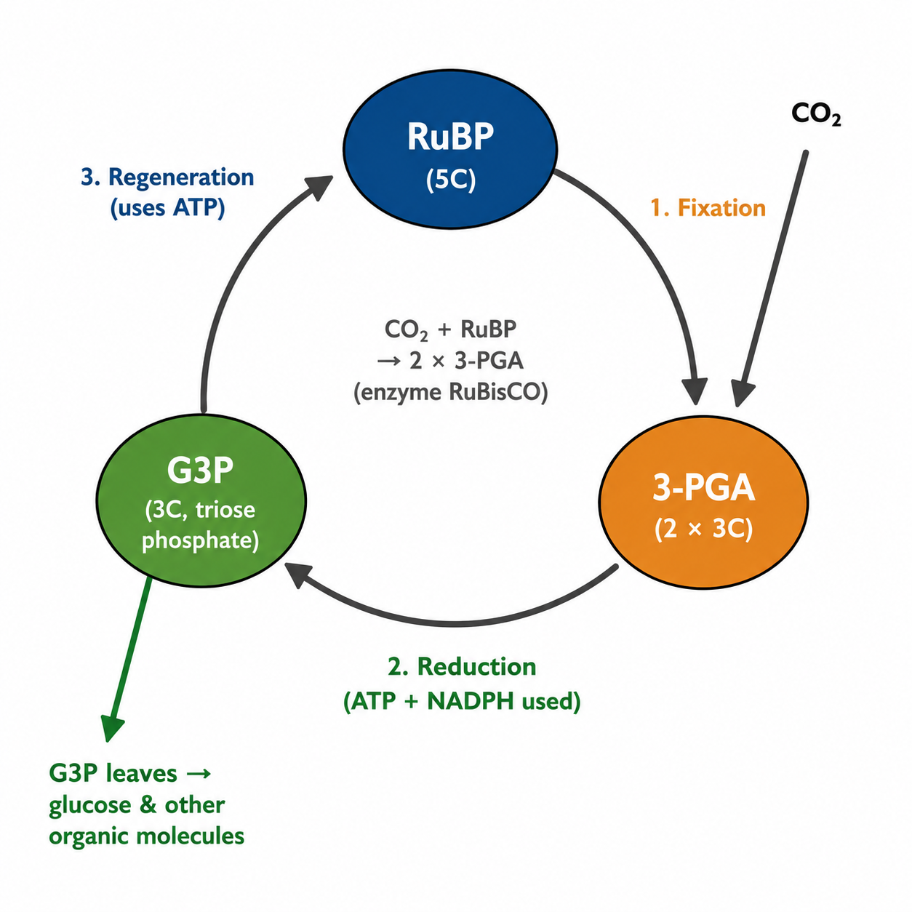
Figure 4: The Calvin cycle - carbon fixation, reduction and regeneration of RuBP in the stroma.

Limiting Factors of Photosynthesis
The rate of photosynthesis is influenced by several environmental factors. At any given time, the factor that is in the shortest supply relative to the plant's needs is known as the limiting factor. This factor determines the maximum rate at which photosynthesis can occur.
If the limiting factor is increased, the rate of photosynthesis will also increase. However, this increase continues only until another factor becomes limiting. At that point, the rate levels off and further increases in the original factor have little or no effect.
The three main limiting factors of photosynthesis are light intensity, carbon dioxide concentration, and temperature.

Light Intensity
Light provides the energy required for the light-dependent reactions. At low light intensities, photosynthesis occurs slowly because insufficient energy is available. As light intensity increases, the rate of photosynthesis rises because more light energy can be absorbed by chlorophyll.
Eventually, the graph reaches a plateau because another factor, such as carbon dioxide concentration or temperature, becomes limiting.

Carbon Dioxide Concentration
Carbon dioxide is a raw material required for the Calvin cycle. At low carbon dioxide concentrations, photosynthesis is restricted because insufficient carbon is available for glucose production.
As carbon dioxide concentration increases, the rate of photosynthesis increases until another factor becomes limiting. Once sufficient carbon dioxide is available, further increases have little effect on the rate.

Temperature
Photosynthesis is controlled by enzymes, particularly those involved in the Calvin cycle. As temperature increases, enzyme activity generally increases, causing the rate of photosynthesis to rise.
However, beyond the optimum temperature, the enzymes begin to lose their structure and function through denaturation. As a result, the rate of photosynthesis decreases rapidly at very high temperatures.

The Law of Limiting Factors
The concept of limiting factors was proposed by the scientist F. F. Blackman. His principle states that when a process depends on several factors, its rate is controlled by whichever factor is in shortest supply.
For example:
- On a cloudy day, light intensity may be the limiting factor.
- In a greenhouse, carbon dioxide concentration may be the limiting factor.
- During very hot weather, temperature may become the limiting factor.
Understanding limiting factors helps scientists and farmers improve plant growth and crop productivity.

Summary of Limiting Factors
Limiting Factor | Effect on Photosynthesis
Light Intensity | Provides energy for the light-dependent reactions
Carbon Dioxide | Provides carbon for glucose synthesis
Temperature | Controls enzyme activity during photosynthesis

Photosynthesis therefore depends on a balance of environmental conditions. Increasing one factor will only increase the rate until another factor becomes limiting.
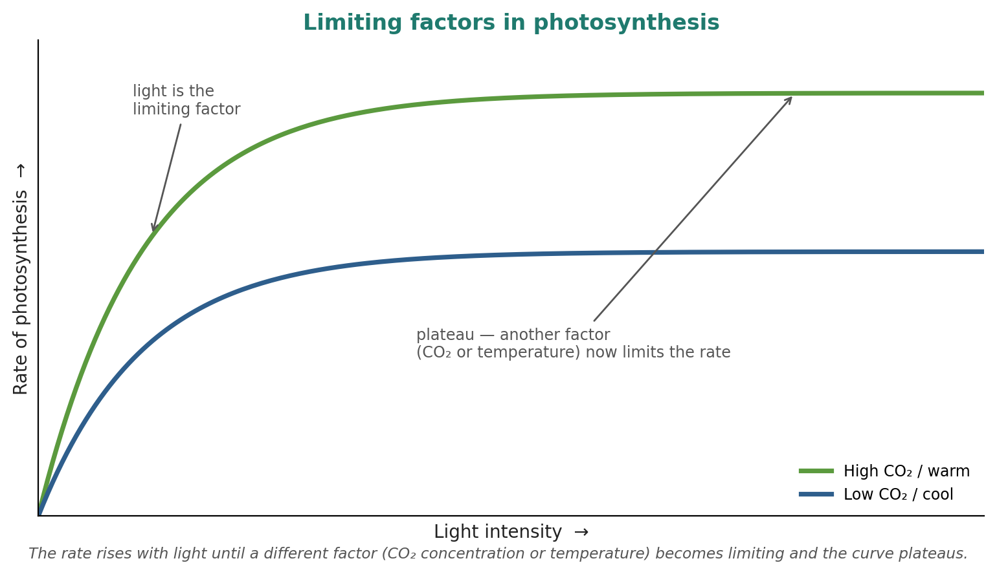
Figure 5: Limiting factors - the rate rises then plateaus as light, CO₂ or temperature becomes limiting.

Worked Example - Reading a Limiting-Factor Graph
Graphs showing the rate of photosynthesis help scientists identify which factor is limiting under particular conditions.
Consider a graph showing the rate of photosynthesis plotted against light intensity.
At low light intensities, the graph rises steeply. In this region, light is the limiting factor, meaning that the plant does not receive enough light energy to maximize photosynthesis. As light intensity increases, more energy becomes available for the light-dependent reactions, causing the rate of photosynthesis to increase rapidly.
As light intensity continues to increase, the graph eventually begins to level off and forms a plateau. At this point, light is no longer limiting because sufficient light energy is available. Instead, another factor such as carbon dioxide concentration or temperature has become the limiting factor.
If carbon dioxide concentration were increased while the graph is at the plateau, the rate of photosynthesis would rise further and the plateau would move higher. This demonstrates how changing the limiting factor can increase the rate of photosynthesis.
When interpreting limiting-factor graphs, remember:
- A rising line indicates that the factor on the x-axis is limiting the process.
- A plateau indicates that another factor has become limiting.
- A falling line (usually with temperature graphs) may indicate enzyme denaturation.
Understanding these patterns helps scientists investigate the factors affecting plant growth and productivity.

Why Photosynthesis Matters
Photosynthesis is one of the most important biological processes on Earth because it provides the energy and organic molecules that support nearly all ecosystems.
- Food Production - Photosynthesis produces glucose, which forms the basis of almost every food chain. Plants are primary producers that supply energy to herbivores, carnivores, and decomposers.
- Oxygen Production - During photosynthesis, oxygen is released as a by-product of photolysis. This oxygen is essential for aerobic respiration in most living organisms.
- Climate Regulation - Photosynthesis removes carbon dioxide from the atmosphere and helps regulate the global carbon cycle. By absorbing carbon dioxide, plants contribute to reducing the effects of climate change.
- Agriculture - Understanding photosynthesis and limiting factors allows farmers to improve crop yields through the management of light, carbon dioxide, water, and temperature.
- Energy for Life - Nearly all energy used by living organisms can be traced back to the Sun and the photosynthetic organisms that capture its energy.

PNG Context Example
In Papua New Guinea, photosynthesis plays a vital role in agriculture, forestry, and ecosystem sustainability. Crops such as sweet potato, taro, banana, and coffee depend on efficient photosynthesis for growth and productivity. Understanding the factors that affect photosynthesis helps improve agricultural practices, increase food production, and support environmental conservation.
Photosynthesis is therefore not only the foundation of plant life but also the foundation of most life on Earth, providing food, oxygen, and energy for ecosystems worldwide.

References & Related Documents

Source Documents
- STEM Biology Student Resource Book - Grade 12. Thema: Energy; Module 12.1 Bioenergy, Topic 1 (Photosynthesis). Department of Education, PNG (2021).
- Biology Standards-Based Syllabus, Grades 11 & 12 (PNG SBC 2020) - Strand 2: Life; examining the chemical reactions of photosynthesis and the cycling of energy.

Further Reading & References
- Alberts, B., et al. (2002). Molecular Biology of the Cell (4th Ed). Garland Science, New York.
- OpenStax Biology - https://openstax.org/books/biology
- National Human Genome Research Institute - https://www.genome.gov

